**FACULTY OF SCIENCE AND** 

**ENGINEERING SEMESTER 2, 2018**

# IAB330 - Mobile App Design

**Assignment 1: App Design**

**Due Date: Friday, August 24, 11:59 pm**

**Submission Method: Blackboard**

**Overview:** You will submit a report that explains the benefits and feasibility of your mobile development project that will be executed throughout the semester. The report includes a survey of related applications, design decisions, and storyboards.

## Submission Cover Sheet Declaration

You must sign below. By signing this form you agree to the following:

* We declare that all of the work submitted for this assignment is our own original work except for material that is explicitly referenced and for which we have permission, or which is freely available (and also referenced).
* We agree that QUT may archive this assignment for an indefinite period of time, and use it in the future for educational purposes including, but not limited to: as an example of previous work; as the basis for assignments, lectures or tutorials; for comparison when scanning for plagiarism, etc.
* We agree to indemnify QUT and hold it blameless if copyright infringements are found in this work and the copyright owner takes action against QUT that is not covered by the normal terms of Educational Use.

The assignment should be completed in a team of 4 students. Please consult with your tutor and unit coordinator if you have any issues.

|  |  |  |
| --- | --- | --- |
| **Chosen Project Name:** | |  |
| **Team Member Details** | |  |
| **Student Number** | **Student Name** | **Signature** |
| N9656286 | Dean mchugh | Dean mchugh |
| N9720316 | Patric Marchant | Patric Marchant |
| N9967273 | Donghyeon Kim | Donghyeon Kim |
| N9460314 | Jade Kelley-Reskic | jkelley |

**Task 1: Project choice and executive summary of the chosen project**

The application we have chosen is the Geospatial Science application. This application will link a collection of scencers and information from mobile devices for mapping a specific area that the user will survey.

This application requires that the user can input data from the local environment and store it inside their personal devices. This data will consist of sensory information and tagging points of interest with specific names and information attached to those locations. The user will want to revue the information they have personally collected on the device as its being collected.

This collected information will need to be held inside the local device until a internet or hard line connection can be established for the transfer of information to the central location information database.

The application will need to download and handle GeoJSON polygon files. These files will import information from the database and display all this information in a generated map of the area around the user. This map will have all the points of interest in the respective locations in a set radius around the user.

The primary users of this application will be the students and instructors of EVB203. The secondary users will be the general public after the app has been finished accepted and finally put in the app store for download by anyone with an interest in mapping their surrounding areas. These potential secondary users could be landscape architects, public transport and other schools geography students.

The user demands for this application is overall simple GUI layout and understandable functionality. This will be required as the app is built and operation will transfer from the primary users to the general public.

Each user will want to have a login so that they can input the data they personally collected into the database creating accountability for the information.

The users will want easy data capturing, including GPS location and elevation.

Other similar mobile apps to our Geo app are the suite of GIS apps that fulcrum developed.

Features: - Highly customizable to create specific data collection sets.

- Accepts geotagged pictures, record videos and collect audio notes

- Accept CVS, XLS and SHP files

Another application is the collector for ArcGIS.

Features: - Access to built in and pre configured web maps

- Collects data while online, offline and syncing when connected

- captures and share photos and videos

This application will fulfill user needs by implementing a user friendly GUI to control the full functionality of the app. The user will be able to capture locational data and input descriptions for the captured locations. These captured locations will be stored in the users personal device until a connection can be established. After connection the export of the collected information to a central database can be achieved.

**Task 2: Background Research and review of related mobile applications**

**Problem Space Presentation and Discussion**

QUT Geo App, is a GIS application. A Geographic Information Systems (GIS) connects data with geography, allowing us to gather valuable location data. Users will first gather data and record onto their local devices, which will be displayed on the map, then users can carefully analyse their collection of data through the user interface or exporting externally.

Majority of the geographic data is taken for granted, common usage for a GIS could be; reporting power shortages without having to go through unnecessary processes, predicting climate change through records of environments, even analysing crime patterns and much more.

Initial stakeholder for Geo App would be for current QUT students to analyse field data within Gardens Point’s campus. However, Geo App isn’t limited by QUT students, it can be utilised by anybody in need, whether it is by professionals, farmers, businesses, personal uses and etc.

<https://gisgeography.com/what-gis-geographic-information-systems/>

**Application Reviews**

**1. Fulcrum**

<https://play.google.com/store/apps/details?id=com.spatialnetworks.fulcrum>

**General Overview and Starting *Fulcrum***

Fulcrum is a hosted mobile forms platform that allows user to build their own data collection form by using existing ‘applications’ to capture the specialised data they desire (2nd photo).

When the user wants to collect their data, they are first prompted to the ‘Add App’ page, this is where the user chooses their field (agriculture, construction, GIS, etc.) to gather the most relevant information.

After user specifies the field, then they are displayed with more advanced features (1st photo), and all the user needs to do, is click on the application and it will automatically install and be ready to use.

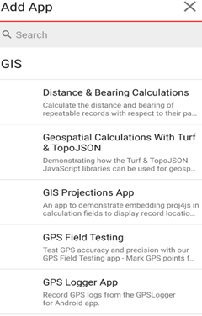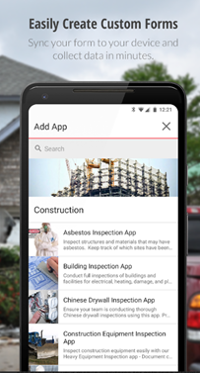

**Data filtering and UI settings.**

Depending on user’s preference, users can also choose how they want the map to be displayed by clicking the small button underneath the search function. (Picture 1).

By tapping the drop-down settings (3 vertical dots), it is shown with 5 options; Synchronize Data, which updates the currently collected data to the database. Place Search, which user can navigate to the specific part of the GUI map by entering the location, (they can also get the current location by clicking the GPS function button on the bottom right). List View / Map view, where users can view all of their collected data through the table list view or directly on the map (2nd photo and the 3rd photo. Record Filter, which filters records with keywords and finally, settings with more general and advanced settings of the application as a whole.

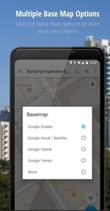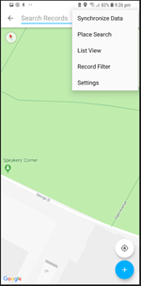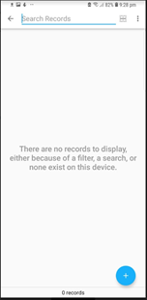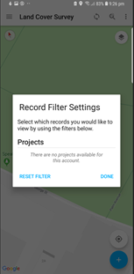

**Gathering and Managing data**

Users can easily input data using the user friendly UI. Firstly they select the location of the data, this can be done in two ways, either manually inputting the latitude and the longitude coordinate (2nd photo), or it could be done with the GPS by grabbing the current user’s location (4th photo).

Then depending on which ‘application form’ you are using to collect data, it will ask about different information of the data inputted. In example, custom projections application will only ask for ‘projection name’ -> ‘x-value’ -> ‘y-value’, however, in the landcover application it will ask for ‘Land cover type’ -> ‘then its related information’ and so on.

Users can also provide visual information about the data, such as capturing a photo or video and submitting the data as a whole. Users can use Fulcrum and gather data offline, meaning that, if the internet connection to the central database has dropped, your collected information will be saved into your local storage and will be synchronized when available, instead of losing the data, a specific data record can be generated into a report (seen in 5th photo), however, this functionality requires internet connection.

To analyse the data, user can access the data from a web portal, where they can review and visualize their collected data as an individual or as a group, also, through the web portal, user can build a customized application form where they may create their personalized application for the collection of the data they need.

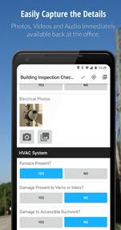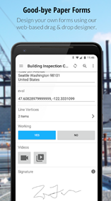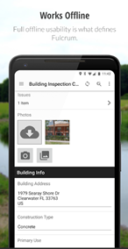

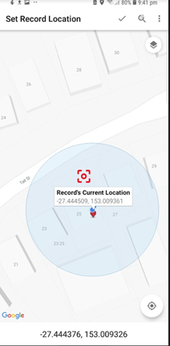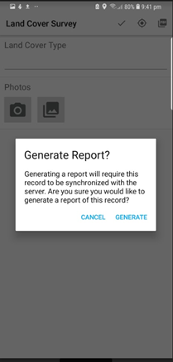

**Positives:**

**Approach –** This applications approaches the main problem many data collectors face, fixed data inputs and loss of data due to demand of internet while using this application.

**Features and functionality –** The key features of this application, would be the ability to work offline, preventing data loss between poor internet connections and variety of application forms to choose from many industries and having the ability to create your own personalized forms to work with, it provides users with great flexibility.

It allows group collaborations and data visualisations with the use of web portals.

**General UI design –** The UI design is very user friendly, everything is laid out in a nice tabular format, with an appropriate sizes for widgets, labels, buttons and forms.

**Page navigation –** The page navigations of this application was very pleasing, having all of the features in a tabular format, it was easy to navigate.

**Negatives -**

**Features and functionality –** The only negatives about this application features would be that after using the 30 day trial of this mobile application, you need to pay a subscription fee.

**Page navigation –** At first, it is difficult to understand how to operate this application, as there are no instructions on using the application, it requires users to play around with the application until they understand the core functionalities and how it works.

**Review**

From reviewing ‘*Fulcrum*’ it would be very useful if we could implement these features

+ Ability to work offline.

+ Instead of inputting each data information one by one, have a quick side bar that allows you to tap on the map and choose recent data type which pre-fills the information.

+ Ability to add visual information into the dataset such as photos.

+ Being able to tap on the map to choose the data location, instead of manually inputting the latitude and the longitude

+ Ability to export every dataset on the map into a pdf or csv file through downloading or email.

**2. ArcGIS**

<https://play.google.com/store/apps/details?id=com.esri.explorer>

<https://play.google.com/store/apps/details?id=com.esri.arcgis.collector>

**General Overview and Starting *ArcGIS***

Esri, the company of ArcGIS, has separated distinct ArcGIS applications which has different intended uses. (Collector, Surveyor, Explorer, Navigator, as seen in 1st picture below). ‘Collector for ArcGIS’ is the application used for collecting data, which is the most related functionality to our application ‘Geo App’.

When first launching the application, the user is greeted with a home page, which consists of ArcGIS’s login page which automatically synchornises your previous collections on your account or just utilizing the application without logging in (2nd photo). Continuing on, users can choose from 7 different types of maps (which is arranged in a tabular format), that changes the way map is displayed and depending on the chosen map, the data that can be collected is also changed, and users are welcome to go back and change their map selection anytime (3rd picture).

Finally, users can operate their data collection while disconnected from internet by downloading the map to your local device (similar to using offline google map navigation), and continue to work on their task without limitations.

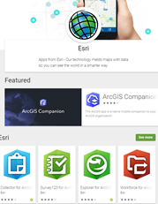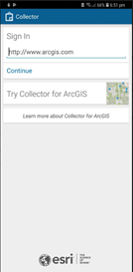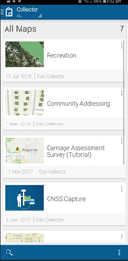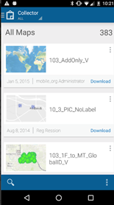

**Gathering data and general UI**

The general UI is good and easy to use, however, one UI design I personally disliked was the navigation bar of the data map page (1st photo), when trying to use the application for data collecting, most of the pop-ups will come up from the bottom (2nd photo), and sometimes it will transfer the user to a new page which demands users to navigate from the top left, which I found somewhat irritating.

Starting from the left of the navigation bar, first is the GPS function, it is used to **toggle** GPS on and off, if the white rectangular box appears above the navigation bar (1st photo) it means the GPS is active, users can then click the white box to view the GPS status (3rd photo), such as horizontal and vertical accuracy, frequency of the GPS update and etc. The second function of the navigation bar is used to record new data onto the map (4th photo), it will prompt the user with the available data type that can be recorded (which is different depending on which map user first chose), in this case it provides users with ‘facilities’, ‘trails’ and ‘Recreational Area’. Once user decides which data type the want to record, it will ask users for more information, where they can input description of the data, physical quality of the data, visual data (photos, videos) and the date it was recorded (5th photo). After user has recorded the data, it can then be visually seen in the map indicated by friendly icons (1st and 6th photo) that can be tapped on for more information. Finally, the search filter and the bookmark function, where users can search through their data with given keyword and bookmarking desired location.

Also, there are 3 other applications which can be integrated with ‘Collector for ArcGIS’ that provides additional functions, such as producing optimal path routes (navigator for ArcGIS) and ‘Explorer for ArcGIS’ which allows you to mark up the map that allows users to input multiple information on a property (e.g. building, house, etc.).

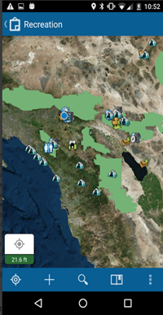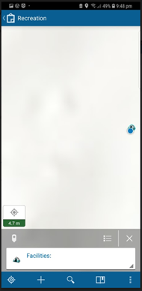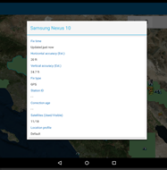

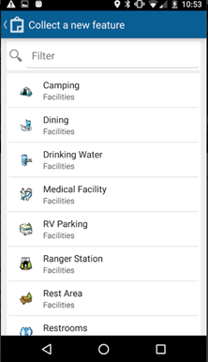 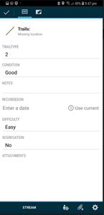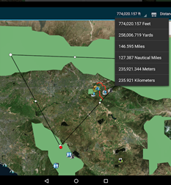

**Positives and negatives of ArcGIS**

**Features and functionality –** There are many functionalities and features included in the ArcGIS, users can work offline by pre-downloading the map data, users can collect, view data in a user friendly UI, use other ArcGIS application, such as ‘Navigator for ArcGIS’, ‘Explorer for ArcGIS’ or Workforce for ArcGIS’ to utilise the data in flexible and multiple ways alone or collaboratively.

The downside of ArcGIS would be that, to experience the maximum potential, users are required to download 4 separate ArcGIS applications and going back and forward between those applications.

**General UI design –** General UI design is user friendly, all UI components are laid in a tabular format with appropriate sizes and good colour contrast, which is pleasant on the eyes.

One great UI feature to be mentioned would be the icon for each individual data, when the data is created, it also produces an user friendly icon on the location of the map, when clicked, directing the user to more descriptive information about the dataset.

**Page navigation –** The page navigations of this application was acceptable, when it comes to collecting data, the navigation bar is fixed to the bottom, however when proceeding further, pop-ups and other inputs are mostly laid on the top making it frustrating for user to operate gracefully.

**Review**

From reviewing ‘*ArcGIS*’ it would be very useful if we could implement these features

+ Making short-cuts of popular data, which in Geo-App it would be; trees, bins, Wi-fi, etc. that would pre-filling redundant information about the data and producing a user friendly icon, providing convenience.

+ Being able to view and click on every dataset on the map, when clicked, providing users with descriptive information.

+ Application as a whole, unlike ArcGIS where it requires user to download multiple application for viewing, collecting, navigating data.

+ Page navigation to be consistent, top left to bottom right, unlike ArcGIS where it is top left to bottom right in the main page, bottom to top in map page, top to bottom in data input page.

+ Multiple pages, ArcGIS crammed all the functionality into one page which was map / data collection page. Instead, we Geo App could have multiple pages for separate uses into a clickable dropdown bar(e.g. collecting data, viewing data, managing data (export / import), settings) and a nav-bar for more direct functions (e.g. in collecting data page, adding data, deleting data, GPS status, etc.)

**B.Mobile App Design**

**Task 1: User Interface**

# Wireframes

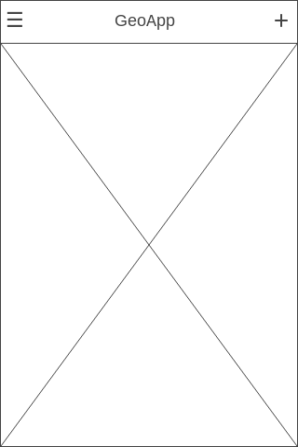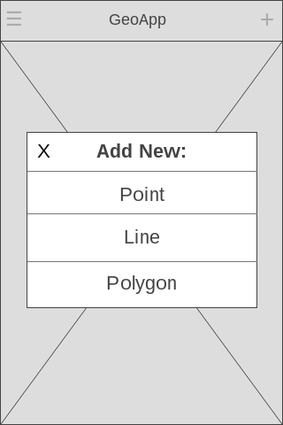

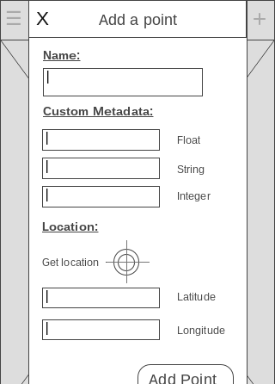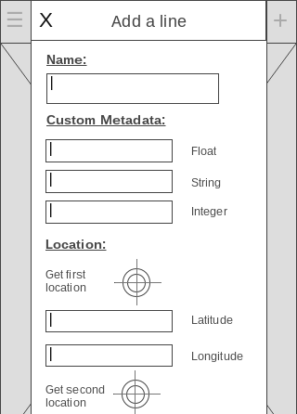



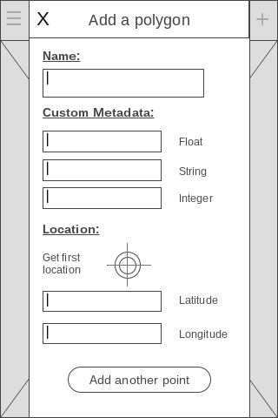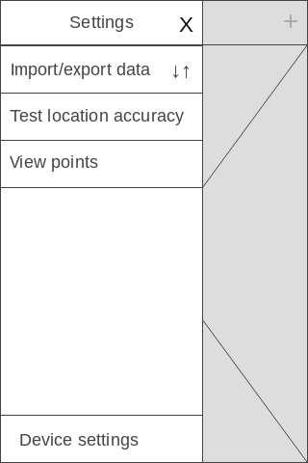





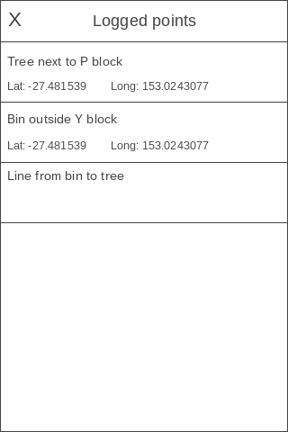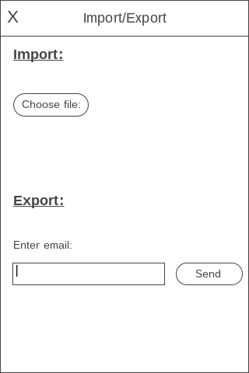



**UI patterns and styling considerations**

When considering the design of our application, we decided to use a number of varying design patterns in our applications UI, this helps the user feel as if they already know how to use the application, and won’t need to spend time trying to figure out how to navigate around the user interface.

# Content scanning

One of the most common UI patterns used in almost every application, including ours, is content scanning, which is relevant not only in software, but in almost every way humans consume information. When most people first see a screen or page of anything, their eyes usually will navigate to the top of the information, and scan horizontally first, and then vertically, like reading a book. Our application is structured in such a way that the title of the page they are on is readable in the navigation bar at the top of the page, which helps the user to know what page in the application they are on and how they can navigate forwards/backwards from it, the main content of the page is then the next part of the page the eyes will lock on to. Our UI is structured this way to promote continual knowledge for the user about where they are in the application/what they can do on the relevant page.

# Navigation Bar

The core design pattern used in every page of our application is the navigation bar, this gives the user a sense of layout in the application, as they are able to know what page they are on in the application (due to the title directly in the middle of the bar), and how they can navigate back to the page they were previously on (back/close button is always positioned on the left side of the bar). In our application, the navigation bar is one of the most important parts of the UX, and is used to do the vast majority of navigating around the application.

# Side Drawer

The application also uses a side drawer which acts as a hub for the menu/settings features in the application such as importing/exporting data, testing location accuracy, viewing points already logged in the app and more. This drawer provides a home for the features in the application that aren’t essential for the basic usage of the app, but are important if you want to get the full functionality of the app.

# 

# List Menu

The list menu design pattern is used when users want to view a comprehensive “list” detailing all of the points marked previously by the user, each entry in the list view shows basic details about each marked point, such as name, Latitude, and Longitude. Although the main screen of the application also shows points already marked, using a secondary feature in the app to view the marked points in a list view provides more readability for users.

In summary, our UI design present in the app provides users with ease of use due to familiarity of the layout’s user interface, as these design patterns are ingrained in user’s subconscious due to them being used so frequently in many other applications they have used. This subtracts from one of the most frustrating parts of using new software/applications; learning how to use/navigate around the user interface.

## 

**Storyboards**

#### General use

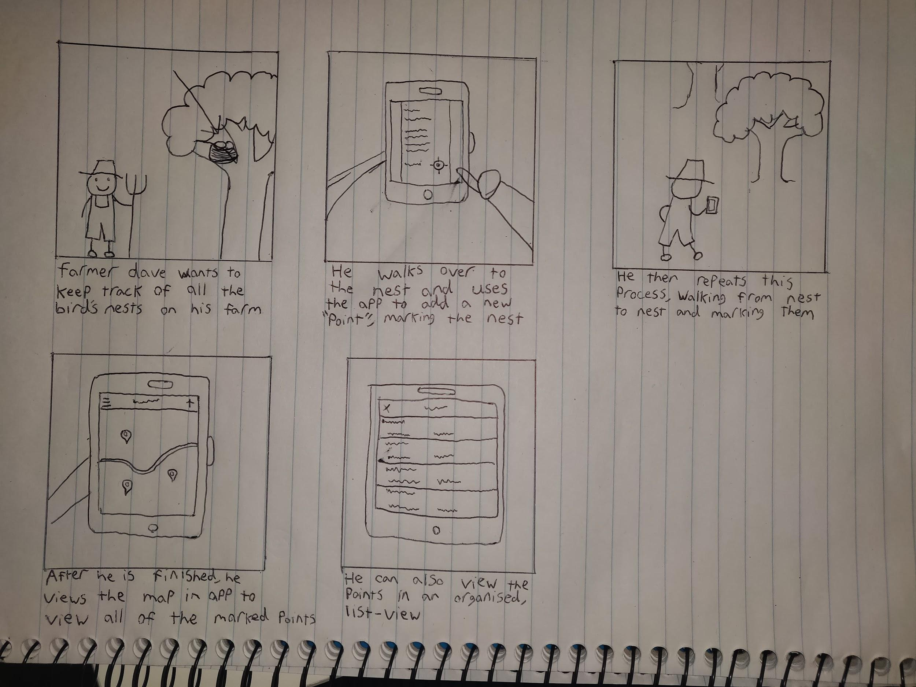

#### Importing/exporting data

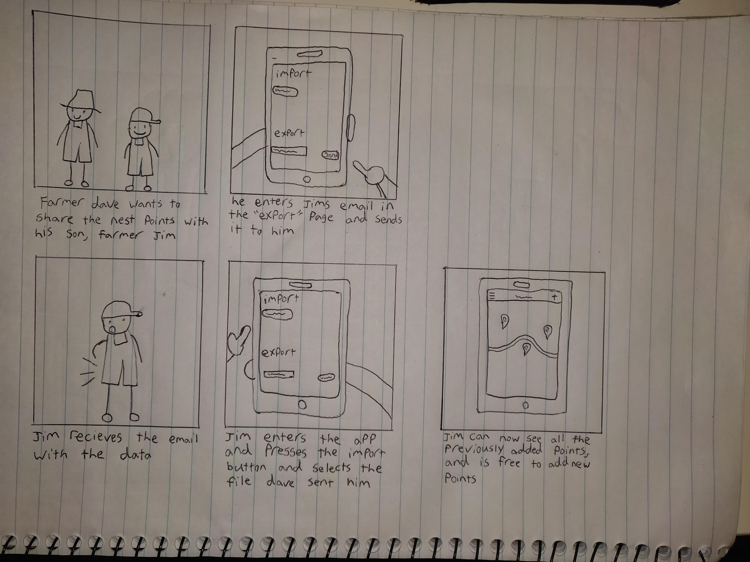

**Task 2: Software Architecture and Implementation**

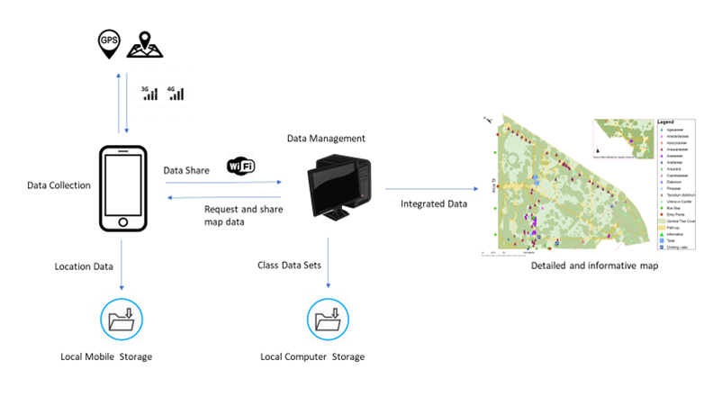

# System Architecture

The system architecture of the GeoApp is illustrated in the diagram above. The application will simply need to collect data about the specified location and export it to a centralized computer for data management. The output is a detailed and informative map based on the integrated class data sets. Using the Global Positioning System (GPS) available on mobile devices, which is enabled through a network connection over 3G or 4G, the user can capture data on a specific location and store it locally on the mobile device. After a session is completed, the user can export the data over Wi-Fi via email attachment. The centralized computer can request for a specific area to be surveyed and update the map on the mobile device using collected data as a way to reduce redundancy of data. Class data sets are accumulated on the local storage of a centralized computer where it is then combined to create a detailed and informative map of the integrated data.

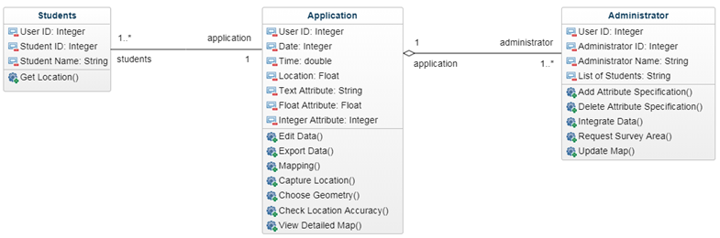

# Software Architecture

The software architecture is shown above in the form of a UML Diagram where it illustrates the encapsulated data model of the application. The software architecture consist of the application class at the centre of the model, where the Student class and Administrator class interacts with it. The relationship between students and the application is a one-to-many to one association, as many students can you use one version of the application. Each student has attributes such as their name, student ID and a method to get their location which is sent to the application to provide them with a unique user ID upon installation and capture their location.

The relationship from the administrator and application is a one-to-many to one aggregation. In this case, the aggregation relationship means that administrators are dependant on the application to collect and export the desired location data. Administrators have attributes which include their name, administrator ID, list of students and methods such as modify attribute, request survey area, update map and integrate data. The application will also provide the administrator a unique user ID and a list of students who are registered on it. The methods allows privileges to the administrators to modify (add or delete) an attribute for meta data, request an area to be surveyed, integrate the data and update the map. By updating the map, which will show the previously surveyed locations, students will be aware of it and duplicate data can be mitigated.

The application is the main component of the data model that connects to both of the users and handles all the necessary operations with the given attributes. The application consist of many attributes such as user ID, date, time, location and metadata attributes(text, float, integer). Students can interact with the mobile application with the various functions available which include choosing a geometry to be collected, capturing the location and filling in the metadata, editing and exporting the data, mapping, checking location accuracy and display a detailed map.

# Flexibility and Maintainability

The data model that was chosen for the development of this application is encapsulation where attributes and methods are grouped into a single class. Encapsulation has many benefits that helps with the flexibility of the code by reducing complexity, and maintainability by protecting the data (private access modifier) from corruption. By considering each component as a single class, flexibility is apparent through the instantiation of objects which can be used throughout the development of the app. This also allows for future changes to include more features, a class can be easily modified to include more attributes and methods.

# Integration

The requirements for the development of the mobile application doesn’t specify a need for a database. However, the system architecture does support for cloud and database integration. As illustrated in the system architecture diagram, the application only needs to export the data as an email to a centralised computer. Cloud computing can be integrated to this system by taking advantage of computing services such as cloud storage, database and networking. Exporting the collected data after each session can become tedious after a while. Incorporating cloud services can be extremely beneficial to the overall system as data can be synced in real time as long as the device has a network connection.

**Testing**

When code isn’t encapsulated, locking down its behaviour within the system that we want to test can become tedious. This can result in a very time-consuming testing as we must resort to simulating the user interacting with the system every time a feature needs to be tested and disable the use of the program interface. Unit testing is the most convenient type of testing because it’s the simplest and the most cost-effective. Code can be tested at the unit level by setting breakpoints which allows the development to be more appropriate as opposed to running the simulator every time a piece of code needs to be checked. Since the data model of our application is well-encapsulated, it will be highly testable as it hides implementation details and can often validate that a certain behaviour is correct. Encapsulated code can be tested at the unit level which eliminates the need for other kinds of non-automated testing.